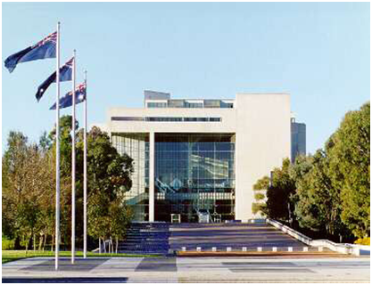
High Court Canberra

Registry Counter Officer HCE Level 3
Non ongoing (12 months) part time position, Sydney
$57,641 to $62,090(pro rata)
plus 15.4% Superannuation

This position is located in Sydney in the Law Courts Building in Queens Square and is a part of the High Court’s Registry Branch. The Registry is responsible for providing information and assistance to legal practitioners and litigants on the jurisdiction, practice and procedure of the High Court. It is also responsible for the filing of proceedings and for collecting and accounting for fees received by the Court.

ABOUT THE JOB

Details: High Court Employee, Level 3
Non ongoing (12 months) part time: up to 3 days per week
Salary: $57,641 to $62,090 (pro rata) plus 15.4% Superannuation
Location: Law Courts Building, Sydney

The Role
Under routine direction, the occupant of this position will perform a range of tasks that contribute to the smooth daily operations of the High Court Registry in Sydney.
Contact Officer
Matt Grey, Deputy Registrar, Ph. 02 9230 8375

Email: hr.officer@hcourt.gov.au

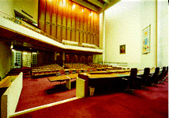Court room 1

THE ROLE

Under supervision, the successful candidate will be responsible for:
- Attending to telephone and counter enquiries. Providing information and assistance to legal practitioners and members of the public regarding matters either filed, or to be filed, in the Court.
- On a daily basis, receiving and dispatching incoming documents both by courier and post.
- Receiving and accounting for statutory fees and charges for services provided by the Court.
- Ensuring the timely distribution and collation of Court documents. Assisting in the maintenance of the Case Management System and the checking of documents for compliance with the requirements of the High Court Rules.
- Providing administrative assistance to the Deputy Registrars as directed.
- Assisting practitioners seeking to enter their names on the Register of Practitioners.

SELECTION CRITERIA
Please concisely describe your skills and experience against the following selection criteria. You are encouraged to use dot points.
- Well-developed communication skills. This should include the ability to respond appropriately, either orally or in writing, to inquiries from justices, practitioners, unrepresented litigants, interpreters and members of the public.
- Knowledge of, or the ability to acquire the knowledge of, the Court’s processes.
- Computer literacy.
- Effective organisation skills. This should include the ability to meet deadlines and to prioritise workloads in a small team environment.
- A high level of accuracy and attention to detail.
Important to note:
- There are no mandatory qualifications for this position. However the study of law, or experience in working in a court/tribunal environment is desirable.
- The successful candidate will also need to comply with both the High Court’s Code of Conduct and the relevant Workplace Health and Safety arrangements.

HOW TO APPLY

For your application to be considered, it must include the following documents:
- an application cover sheet (refer page 7)
- your current resume
- a statement addressing the selection criteria

Preference is for electronic lodgement of applications by email to the HR Manager, hr.officer@hcourt.gov.au . A hard copy application may be lodged by post to:
HR Manager
High Court of Australia
PO Box 6309
KINGSTON ACT 2604
The closing date for applications is 31 May 2018.
Please note that the High Court does not send out letters to unsuccessful applicants. All interviewees however will be advised of the outcome of their interview and offered feedback.
Court room 1 front doors

CONDITIONS OF ENGAGEMENT

Employees of the Court are employed under the High Court of Australia Act 1979, with the Determination under s26 (4) of the High Court of Australia Act 1979 Terms and Conditions of Employment of Employees. The following pre-employment checks will be conducted prior to the commencement of employment:
Australian citizenship evidenced by an Australian birth certificate or passport, or a certificate of Australian citizenship for applicants born overseas.
A 100 point identity check. In the case of a name change, a marriage certificate, deed poll or other legal evidence must also be provided.
A previous employment/reference check.
A criminal history check.
A pre-employment medical exam.
All employees are subject to a 6 month probationary period.
Please note that the High Court of Australia is not an APS employer, but it will recognise prior service with qualifying government employers.

HIGH COURT OF AUSTRALIA
APPLICATION COVER SHEET
Position Title: | Registry Counter Officer- Sydney  Temporary part time | Position Classification: | HCE Level 3
Personal Details
Title |  | Surname
Given Names |  | Date of Birth  (optional)
Postal Address
Contact Phone No (business hours)
Mobile Phone No
You must be an Australian citizen to be eligible for employment at the High Court of Australia.
Do you have any restrictions that may prevent your employment with the High Court? Yes/no
Are you an Australian citizen? (Please circle or delete) YES / NO
Do you require assistance in attending an interview? Yes/No if yes please advise your requirements

Are you currently a Commonwealth, APS or State government employee? (Please circle) Department/Agency name: |  |  |  | YES / NO
AGS number
Nominal Level |  | Actual Level
Ongoing Employee | Yes/No | Non-ongoing employee | Yes/No
Have you received a redundancy from a Commonwealth, APS or state government employer in the last 12 months? (Please circle or delete) |  |  | YES / NO

Referee 1 Details |  |  | Referee 2 Details
Name: |  |  | Name:
Title: |  |  | Title:
Organisation: |  |  | Organisation:
Phone No: |  |  | Phone No:

