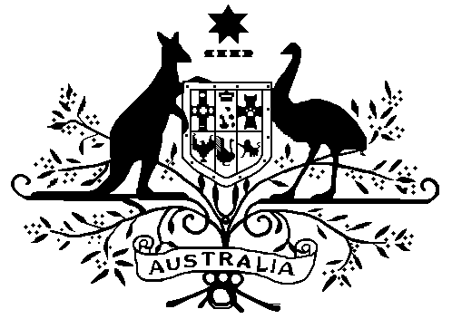
HIGH COURT OF AUSTRALIA

PRACTICE DIRECTION NO 1 OF 2023

HIGH COURT RULES 2004 APPROVED FORMS

      - Purpose

This Practice Direction amends the form of:

Form 17 Application for removal
Form 18 Response to application for removal
Form 23 Application for leave or special leave to appeal
Form 23A Response to application for leave or special leave to appeal

      - Commencement
This Practice Direction takes effect on 1 December 2023.

      - Practice Direction No 1 of 2022

Practice Direction No 1 of 2022 is revoked.

      - Approved forms

The Justices of the High Court of Australia approve the forms annexed to this Practice Direction for the purposes of the High Court Rules 2004.

A reference in the High Court Rules 2004 to a form by number is a reference to the form so numbered and approved by this Practice Direction.

13 November 2023

