HIGH COURT OF AUSTRALIA

EDELMAN, STEWARD AND GLEESON JJ

SAN BAO PTY LTD PLAINTIFF

AND

MINISTER FOR IMMIGRATION AND CITIZENSHIP DEFENDANT

San Bao Pty Ltd v Minister for Immigration and Citizenship
[2026] HCA 6
Date of Judgment: 11 March 2026
S160/2025

ORDER

Application dismissed with costs.

Representation

The plaintiff is represented by Kingstone Lawyers

The defendant is represented by Sparke Helmore

Notice: This copy of the Court's Reasons for Judgment is subject to formal revision prior to publication in the Commonwealth Law Reports.

CATCHWORDS

San Bao Pty Ltd v Minister for Immigration and Citizenship

Administrative law – Judicial review – Jurisdictional error – Where application for approval of nomination of individual for Subclass 482 (Skills in Demand) visa refused – Where refusal was based, amongst other things, on consideration of documents and information provided by plaintiff – Where delegate not satisfied that position associated with nominated occupation is genuine – Where application for constitutional or other writ is brought because no other tribunal or court has jurisdiction, respectively, to review or judicially review decision – Whether delegate of Minister constructively failed to exercise jurisdiction by refusing nomination application – Whether delegate's decision was legally unreasonable.

Words and phrases – "abuse of process", "business sponsor", "constitutional writs", "constructive failure to exercise jurisdiction", "delay", "jurisdictional error", "legally unreasonable", "nomination", "organisational chart", "original jurisdiction", "Skills in Demand", "unavailability of the usual court process".

Administrative Review Tribunal Act 2024 (Cth), ss 18(1), 295(1).
Administrative Review Tribunal Rules 2024 (Cth), r 6(3).
High Court Rules 2004 (Cth), r 25.02.
Migration Act 1958 (Cth), ss 140E, 140GB, 338(1), 338(9), 476, 476B.
Migration Regulations 1994 (Cth), regs 2.58(1)(a), 2.59, 4.02(4)(d), Div 2.17.

EDELMAN, STEWARD AND GLEESON JJ.

This application and obstacles to the use of constitutional writs in this Court
- The plaintiff, San Bao Pty Ltd ("the Company"), is a company that operates a restaurant in Sydney serving authentic Chinese street food under the brand "Yummy Street Food". On 20 November 2025, the Company filed this application for a constitutional writ of certiorari—to quash the decision of a delegate of the defendant, the Minister for Immigration and Citizenship ("the Minister"), made on 16 October 2025, which refused the Company's application for nomination of a Subclass 482 (Skills in Demand) visa—and for a constitutional writ of mandamus, requiring the Minister to determine that nomination application according to law.
- The Company asserts, and there is no dispute by the Minister, that it brought the application for constitutional writs in this Court because no other tribunal or court has jurisdiction, respectively, to review or judicially review the decision. The Company accepts that the reason for the need to bring the application in this Court is that the Company did not challenge the decision of the Minister within the 28-day period for seeking review by the Administrative Review Tribunal ("the ART"). Since the challenged decision of the Minister is a "reviewable migration decision" which is sought to be challenged outside the prescribed time period, the decision is a "primary decision" and the Federal Circuit and Family Court of Australia (Division 2) has no jurisdiction to judicially review the decision. The matter cannot be remitted to that court. Nor, in the absence of any jurisdiction conferred upon the Federal Court of Australia (and the parties did not point to any), can this Court remit the matter to the Federal Court or to any other court.
- Although the Company has brought its application for constitutional writs within the time limits required in this Court, the original jurisdiction of this Court does not exist as a concurrent review mechanism for a plaintiff who, for some reason, does not file an application for review of a decision within strict time limits provided by legislation or legislative instruments. Other than in exceptional cases, where the importance, merits, or urgency of a case requires otherwise, the usual process which an application for review, application for judicial review, or appeal should follow is through the hierarchy of tribunals and courts culminating (usually after satisfying the requirement of special leave to appeal) in a decision of this Court. That is why it will often be an abuse of process to seek to circumvent that hierarchy, or to revisit the result of decisions made within that hierarchy, by invoking the original jurisdiction of this Court.
- The mere unavailability of the usual court process of an application for review, application for judicial review, or appeal through the hierarchy of tribunals and courts is not, by itself, an exceptional reason for invoking the original jurisdiction of this Court to correct an asserted jurisdictional error. For instance, it would likely be an abuse of process for an applicant to seek to pursue a parallel route of invoking the original jurisdiction of this Court by deliberately abstaining from seeking relief through the usual tribunal and court processes until those processes are unavailable. The same may also be true in an assessment of all the circumstances where one factor is that the reason for the delay is the manifest fault of the plaintiff.
- In this application the Company provided no evidence at all concerning the reasons for delay and the expiry of time which precluded the availability of the usual tribunal and court processes. That glaring absence might, by itself, be sufficient to dismiss the application. Nevertheless, a "prudential" approach can be taken to this application, assessing it on its merits, in circumstances in which: (i) the parties agreed that this application should be dealt with on the papers by a Full Court; (ii) the Minister did not make any submission that the application should be dealt with other than on its merits; and (iii) our conclusion is that the application should be dismissed on the merits.

The merits of the Company's application

The legal regime for business sponsorship and nomination
- Section 140E(1) of the Migration Act 1958 (Cth) provides that the Minister "must approve a person as a work sponsor" in relation to certain prescribed classes of work sponsor if "prescribed criteria are satisfied". One of the prescribed classes is that of "standard business sponsor". The Migration Regulations 1994 (Cth) provide for criteria that must be satisfied for the Minister to approve an application under s 140E(1) by a person to be a standard business sponsor.
- Section 140GB(1)(a)(i) of the Migration Act relevantly provides that "[a] person who is, or who has applied to be, an approved work sponsor ... may nominate ... an applicant, or proposed applicant, for a visa of a prescribed kind (however described), in relation to ... the applicant or proposed applicant's proposed occupation". Section 140GB(2)(b) provides that the Minister must approve a person's nomination if, amongst other conditions, the prescribed criteria are satisfied.
- Division 2.17 of the Migration Regulations ("Nominations") applies, amongst other things, to any person who is, or has applied to be, a standard business sponsor. Within Div 2.17, reg 2.72 provides for the criteria for approval of various nominations, including a nomination of a proposed occupation in relation to an applicant or a proposed applicant for a "Subclass 482 (Skills in Demand) visa". One of the criteria, provided by reg 2.72(10)(a), is that "[t]he Minister is satisfied that the position associated with the occupation is ... genuine".

The Company's applications
- On 5 June 2025, the Company lodged with the Department of Home Affairs an online application for standard business sponsorship under reg 2.59 of the Migration Regulations. As part of that application the Company uploaded an organisational chart which showed the organisational structure for the Company. The organisational chart was a single page as annexed to these reasons.
- The organisational chart said nothing about how the various positions related to each other. For instance, the organisational chart revealed that the Company presently employs two cooks and a pastry cook, and was proposing to employ two further cooks and a further pastry cook. But, although the proposed two further cooks and pastry cook were listed on a row below the present cooks and pastry cook, it was not clear whether the two further cooks would assist the present cooks. Nor did the organisational chart say anything about the division of duties amongst all the cooks.
- The Company separately lodged a nomination application concerning a proposed occupation in relation to Ms Haiming Du for a Subclass 482 (Skills in Demand) visa under reg 2.72 of the Migration Regulations. The nomination application was eight pages. It described the operation of the Company's Burwood restaurant and the crucial role that a skilled cook plays in the operations of the restaurant. The application referred to the "upcoming Hurstville store", how that store would affect the scale of the Company’s operations, and the need for additional cooks.
- The nomination application described how, although the Company had become familiar with the nominee months before making an offer of employment to her, an offer of employment to the nominee was not initially feasible due to "the uncertainty surrounding the timeline for the Hurstville restaurant's acquisition, renovation and opening" and how efforts had been made to re-engage with the nominee as the opening date for the Hurstville restaurant drew closer. The application then described how the nominee had been shown the Burwood restaurant and had been given an outline of the Company's growth plans. The application said that the nominee had agreed to join the "team".

The delegate's decisions
- On 16 October 2025, a delegate of the Minister wrote to the lawyers for the Company, approving the Company's application to be a standard business sponsor. On the same day, the same delegate wrote to the lawyers for the Company refusing the Company's nomination application for Ms Haiming Du for a Subclass 482 (Skills in Demand) visa. The letter from the delegate advised the Company of its rights to apply within 28 days to the ART for merits review of the decision, and the inability to extend the time for making such an application.
- The delegate's reasoning in their refusal of the Company's nomination application included the following: (i) noting that they had considered documents and information provided by the Company as well as relevant information held on Departmental files; (ii) explaining that a requirement under reg 2.72 is that the Minister is satisfied that the position associated with the occupation is genuine; (iii) observing that the Company currently has seven employees working in the business (four Australian and three foreign employees); and (iv) concluding that in light of "concerns", the Company had not provided sufficient evidence to satisfy them that "the position associated with the nominated occupation is genuine" within the application of the criterion in reg 2.72(10)(a).

The jurisdictional errors asserted by the Company
- The Company seeks constitutional writs based upon two asserted jurisdictional errors. First, the Company argues that the delegate constructively failed to exercise jurisdiction by refusing the nomination application "on the mistaken premise that no organisation[al] chart had been provided", when an organisational chart was provided with the separate application by the Company for standard business sponsorship. Secondly, the Company asserts that the delegate's decision was legally unreasonable because it "rested on the plainly incorrect premise that no organisation[al] chart or staffing-structure evidence had been provided". It appears that the Company's unreasonableness ground was not that the delegate had acted unreasonably in the exercise of power involving the final decision itself but that the unreasonableness resided in an exercise of power concerning the process of making that decision. In Minister for Immigration and Citizenship v Li, three members of this Court endorsed reasoning of Mason J in Minister for Aboriginal Affairs v Peko-Wallsend Ltd, and said that "the preferred ground for setting aside an administrative decision which has failed to give adequate weight to a relevant factor of great importance, or has given excessive weight to an irrelevant factor of no importance, is that the decision is 'manifestly unreasonable'".
- If the delegate had erred in failing to realise that an organisational chart had been provided with the Company's separate application for standard business sponsorship, then there might nevertheless have been serious doubt as to whether this error could have amounted to a constructive failure to exercise jurisdiction in circumstances in which the delegate directly addressed and decided the nomination application based upon reg 2.72(10)(a). There might also have been serious doubt about whether the error was a relevant factor of great importance capable of supporting a conclusion of unreasonableness in the process of decision-making. It is unnecessary to resolve these issues because the delegate made no error.

No error was made by the delegate
- Contrary to the Company's submissions, the delegate did not refuse the nomination application "on the basis of 'no evidence' of an organisation[al] chart". Nor, again contrary to the Company's submissions, did the delegate "identif[y] the absence of an organisation[al] chart ... as the very decisive deficiency underpinning the refusal". The Company's submissions take the reasoning of the delegate out of its context.
- As explained above, the conclusion of the delegate was that the Company had not provided sufficient evidence to satisfy them that "the position associated with the nominated occupation is genuine" within the application of the criterion in reg 2.72(10)(a). One of the concerns expressed by the delegate was that the Company "did not provide sufficient information to substantiate the nomination of cook in the business". The delegate noted that the Company already had two cooks and "[m]ore importantly, given there are two cooks in the busines[s], insufficient evidence has been provided as to how all the duties are split between the three cooks". The delegate explained:
"While some of the duties to be performed by the nominee appear at face value to be consistent with those of the nominated occupation I am not satisfied that in the context of the applicant's business, the majority of the tasks that the nominee is actually likely to perform align substantially with the tasks of the nominated occupation."
- It was in this context that (without the emphasis added below) the delegate said that "[t]here is no evidence of [an] organisation[al] chart for their business to reflect the existing positions within the business, to show how the nominated position fits into the staffing structure of the business except for a declaration in their genuine position statement that there is a chef and cooks in the business". And it was in the same context that (without the emphasis added below) the delegate said that "in the absence of ... definitive and well identified roles in the form of a business organisation structure, I therefore have serious concern that the nominee may perform roles that are outside or below the scope of a Cook ... as described in [the Australian and New Zealand Standard Classification of Occupation]".
- When the references by the delegate in their reasons to an "organisation[al] chart" are properly understood in their context, it can be seen that the delegate was concerned with the absence of sufficient evidence, including from an organisational chart, that explained the need for an additional cook by detailing the relationship that the additional cook would have within the existing structure. That relationship, it might be inferred, would include chains of responsibility and the division and allocation of duties of cooks (both amongst themselves and in relation to other employees), including across the two locations of the Company's operations.
- There is, therefore, no sufficient basis to infer that, despite the delegate being the same person who approved (on the same day as the refusal of the nomination application) the Company's application to be a standard business sponsor, and despite the delegate's statement that relevant information held on Departmental files had been considered, the delegate had mistakenly thought that no organisational chart had been provided. The far more obvious inference, consistent with the reasoning of the delegate, is that the organisational chart provided by the Company did not provide evidence of how the position of additional cook would fit within the "staffing structure of the [existing] business", in particular "how all the duties are split" to support the need for the additional cook.

Conclusion
- The Company's application should be dismissed with costs.

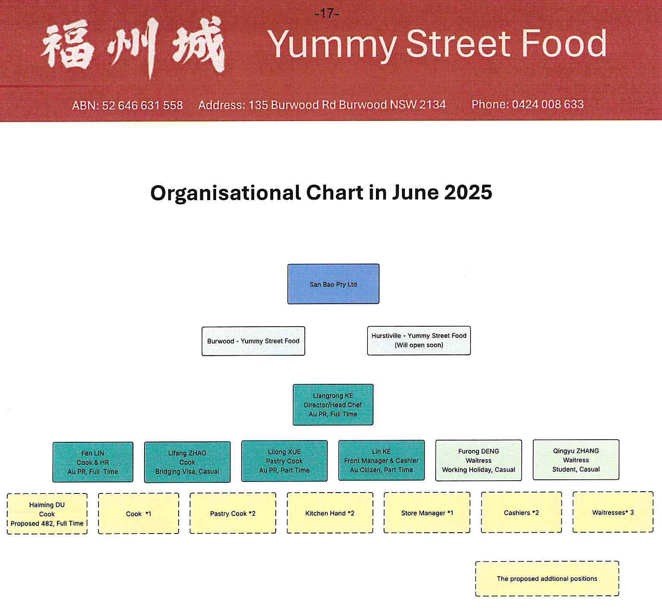
Annexure: Organisational chart showing organisational structure of San Bao Pty Ltd, trading as "Yummy Street Food"

Migration Regulations 1994 (Cth), reg 2.72.
Administrative Review Tribunal Act 2024 (Cth), ss 18(1), 295(1); Administrative Review Tribunal Rules 2024 (Cth), r 6(3).
Migration Act 1958 (Cth), ss 140GB(2), 338(1) and (9) read with Migration Regulations, reg 4.02(4)(d).
Migration Act, s 476(2)(a) and (4)(b).
Migration Act, s 476B(2).
Migration Act, s 476B(1) and (3).
High Court Rules 2004 (Cth), r 25.02.
Bussa v Minister for Immigration, Citizenship, Migrant Services and Multicultural Affairs (2020) 94 ALJR 497 at 501 [13]; 377 ALR 228 at 232.
Compare Tu'uta Katoa v Minister for Immigration, Citizenship, Migrant Services and Multicultural Affairs (2022) 276 CLR 579 at 609 [64].
Migration Act, s 140E(2) read with Migration Regulations, reg 2.58(1)(a).
Migration Regulations, reg 2.59.
Migration Regulations, reg 2.70(a)(i).
(2013) 249 CLR 332 at 365-366 [72].
(1986) 162 CLR 24 at 41; see also at 30, 71.

