

**HIGH COURT OF AUSTRALIA**

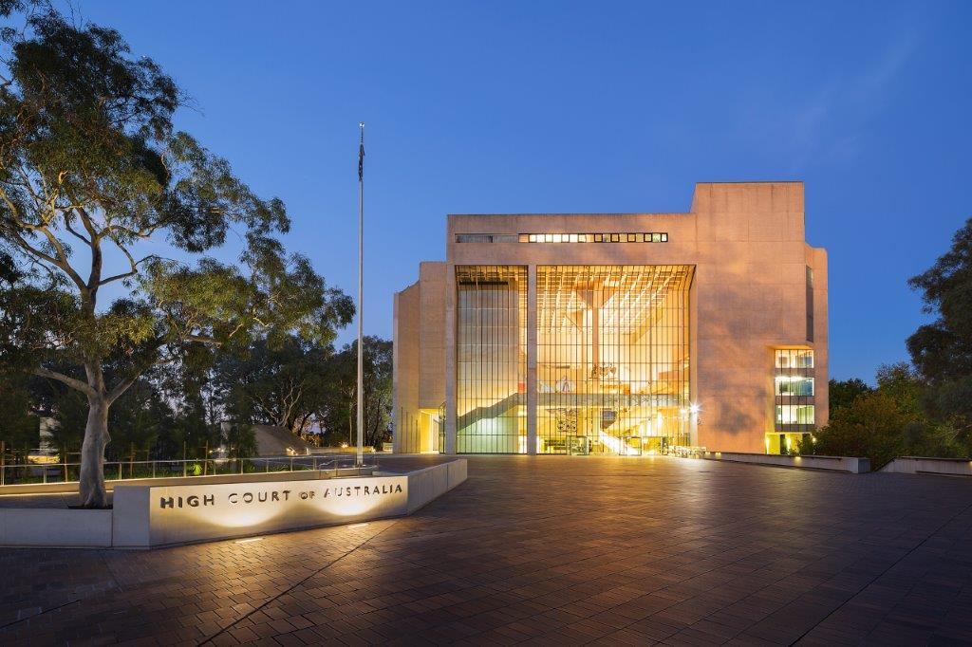

**Vacancy Information Kit**

|  |  |
| --- | --- |
| Position details | |
| Position number | PN 40 |
| Position title | Executive Assistant to the Chief Justice |
| Classification | High Court Employee Level 6 ($93,824 - $106,688) + 8% allowance |
| Location | Canberra, ACT or Sydney NSW |
| Working arrangements | Full‑time Ongoing |
| Eligibility | Employees of the High Court are required to be Australian citizens and must be able to obtain and maintain a Baseline Security clearance. |
| Contact officer | Leonie Young  Email: leonie.young@hcourt.gov.au |
| Closing date | Sunday, 17 August 2025 at 11:55pm AEST |

## About the High Court of Australia

The High Court of Australia (the Court) is the highest court in the Australian judicial system. It was established in 1901 by section 71 of the Constitution.

The seat of the Court is in Canberra, where it is located in its own building within the Parliamentary Triangle. The Court also has locations in Brisbane, Sydney, and Melbourne, as well as sitting on circuit around Australia as required.

Opened in 1980, the High Court building is one of Australia’s National Buildings, and was heritage listed in 2007.

The Court has approximately 75 full-time equivalent ongoing and casual employees supporting the Chief Justice and Justices, most of whom are located in Canberra.

As an employee of the Court, you will:

* work in a high-performing, inclusive and collaborative work environment
* have access in Canberra to reasonably priced undercover car parking
* be appointed under the *High Court of Australia Act 1979*, noting the terms and conditions of employment are similar to those of the Australian Public Service.

## Chambers overview

The Chief Justice of the High Court of Australia leads the court and has general oversight of its administration. In addition, the Chief Justice has a number of extra-curial roles and responsibilities, including national and international engagement.

The Chief Justice’s chambers include:

* The Chief Justice
* The Chief of Staff to the Chief Justice
* Executive Assistant
* Associates.

The Executive Assistant provides high level administrative support to the Chief Justice and chambers staff, including diary management, handling of correspondence as well as travel and hospitality arrangements.

## What you need to be successful

Under the direction of the Chief of Staff, the Executive Assistant is responsible for providing a high level of executive support including:

* supporting day-to-day tasks within the Chief Justice’s Chambers, including managing multiple calendars, scheduling of meetings, email triage, official hospitality and travel bookings.
* handling incoming and outgoing communications and correspondence
* demonstrate high level organisational skills
* demonstrate superior attention to detail and the ability to work autonomously, including demonstrated experience in coordinating high volumes of work whilst meeting strict deadlines and anticipating priorities.
* transcribing and preparing correspondence, speeches and other documents
* work with other chambers and Court staff in relation to administrative and other matters.

This position would suit a proactive and flexible individual with a minimum of five years’ experience providing high level support to a Senior Executive or equivalent.

## Are you eligible to apply?

To be eligible for employment at the Court candidates must be Australian citizens.

Candidates offered employment will be required to successfully undergo a police record check and be able to obtain and maintain a Baseline security clearance. Successful applicants engaged by the Court will be subject to a probation period.

## What does the selection process look like?

The Court uses a range of assessment processes to assist us in selecting suitably qualified and experienced applicants. We uphold the Merit Principle, and our processes are designed to select the best person for the role.

|  |  |
| --- | --- |
| What are the steps? | |
| Apply | Complete and submit your application — see below (max. 750 words), and a résumé of no more than two pages. |
| Shortlist | Applicants for this process will be assessed on their written application against the selection criteria. |
| Interview | Shortlisted applicants will be invited to attend an interview. Interviews may be held in person, or by telephone or video. |
| Work Sample Test | Applicants may be asked to complete a work sample test either in person or remotely. |
| Referees | Referees may be contacted for further assessment of suitability. Applicants should choose referees who can comment effectively and accurately on their current skills and abilities, experience and work performance that is relevant to the duties of the position. |
| Process Complete | After the Chief Executive and Principal Registrar (CE&PR) has approved the process, a merit pool may be established. All candidates will be notified of the outcome and will be provided with an opportunity for feedback. |

## What we need from you

Applications must be addressed to the contact officer and forwarded to the [HR Officer](mailto:hr.officer@hcourt.gov.au) by the closing date.

As part of your application, you will need to provide:

* an application cover sheet
* your current résumé
* a statement of claims (max. 750 words) against the selection criteria, including relevant examples
* the names and contact details of two referees, one of whom should be a current supervisor.

If you have any questions regarding the recruitment process or require any reasonable adjustments, please email the [HR Officer](mailto:HR.Officer@hcourt.gov.au) or telephone (02) 6270 6952.

***Please note that late applications will not be accepted.***

## Selection criteria

The selection criteria reflect the knowledge, experience, core skills and personal qualities required for the role:

* demonstrated experience in a similar Executive Assistant role providing high level executive and personal support to a Senior Executive or equivalent.
* demonstrated interpersonal skills with the ability to build strong working relationships with a wide range of stakeholders
* well-developed organisational and administrative skills including the ability to manage competing priorities and deliver a very high standard of work
* exercise sound judgement and show a high degree of initiative, integrity and discretion when dealing with confidential and sensitive matters
* demonstrated proficiency in the use of IT platforms, including web-based and Microsoft Office applications, record management and travel systems.

|  |  |
| --- | --- |
| Qualifications and experience | |
| Highly Desirable | * Previous experience in a court or legal environment will be highly regarded. * An understanding of and experience in public sector frameworks, policies and procedures is desirable |

## Preparing your statement of claims

Your statement should be succinct and showcase your skills, knowledge, experience and qualifications.

Try not to duplicate information that can be found in your résumé however, you should highlight:

* how your experience, abilities, knowledge and personal qualities would enable you to perform the duties and meet the technical and behavioural capabilities of the role
* any specific examples or achievements that demonstrate your ability to perform the role
* how you meet the eligibility requirements and qualifications for the position.

## Offers and merit pool

At the end of the recruitment process a merit pool may be created. Candidates who are found suitable will be advised that they have been placed in the merit pool, noting that this is not an offer of employment.

The merit pool is valid for 18 months from the date the process is advertised and may be used throughout the year to fill similar positions in the event positions become vacant.

## How we will communicate with you

Please ensure that the contact information you supply is up to date. Your email address will be our primary point of contact during the application process.

Please contact the [HR Officer](mailto:HR.Officer@hcourt.gov.au) if at any stage you are no longer available to be considered for this role.

## 

|  |  |
| --- | --- |
| Application Cover Sheet | |
| Position Title | Executive Assistant to the Chief Justice |
| Position Classification | High Court Employee Level 6 |
| Personal Details | |
| Given Names |  |
| Surname |  |
| Address |  |
| Contact No |  |
| Email |  |
| Are you an Australian citizen? |  |
| Are you currently a Commonwealth, APS or State government employee? |  |
| Department name |  |
| AGS No |  |
| Substantive level |  |
| Ongoing /Non-ongoing |  |
| Have you received a redundancy from a Commonwealth, APS or state government employer in the last 12 months? |  |
| Referee Details |  |
| **Referee No 1 - Name** |  |
| Title / Organisation |  |
| Contact No |  |
| Email |  |
| **Referee No 2 - Name** |  |
| Title/Organisation |  |
| Contact No |  |
| Email |  |
| **How did you hear about this vacancy?** |  |