

**HIGH COURT OF AUSTRALIA**

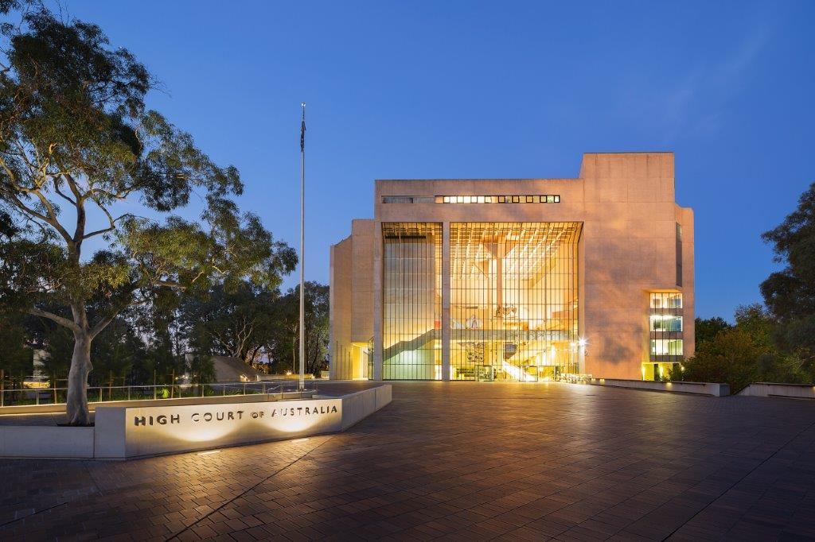

**Vacancy Information Kit**

|  |  |
| --- | --- |
| Position details | |
| Position number | PN 342 |
| Position title | Manager Building Operations |
| Classification | High Court Employee Executive Level 1 ($119,074 - $132,232) |
| Location | Canberra, ACT |
| Working arrangements | Full‑time Ongoing |
| Eligibility | Employees of the High Court are required to be Australian citizens and must be able to obtain and maintain a Negative Vetting 1 security clearance prior to commencement. |
| Contact officer | Chris O’Neill  Tel: 02 6270 6851 |
| Closing date | Sunday, 17 August 2025at 11:55pm AEST |

## About the High Court of Australia

The High Court of Australia (the Court) is the highest court in the Australian judicial system. It was established in 1901 by section 71 of the Constitution.

The seat of the Court is in Canberra, where it is located in its own building within the Parliamentary Triangle. The Court also has locations in Brisbane, Sydney, and Melbourne, as well as sitting on circuit around Australia as required.

Opened in 1980, the High Court building is one of Australia’s National Buildings, and was heritage listed in 2007.

The Court has approximately 75 full-time equivalent ongoing and casual employees supporting the Chief Justice and Justices, most of whom are located in Canberra.

As an employee of the Court, you will:

* work in a high-performing, inclusive and collaborative work environment
* have access to reasonably priced undercover car parking
* be appointed under the *High Court of Australia Act 1979*, with terms and conditions of employment similar to those of the Australian Public Service.

## Branch overview

The Corporate Services Branch provides a high-standard of support and guidance to the Court on general day-to-day requirements. This includes the Administration, Finance, Records Management, Information and Communication Technology (ICT) and Building Operations functions which support the operation of the Court.

Each of these key supporting areas of the Court play a pivotal role, ensuring all employees of the Court are able to successfully undertake the duties of their role within a safe, secure and suitable environment.

The Manager Building Operations reports to the High Court Marshal, Manager Facilities and Security and will be involved in the coordination of Building operations.

The Building Operations Section is responsible for the provision of a range of Building facility services to the Court.

## What you need to be successful

The Manager Building Operations role is responsible for the management of contractors providing facilities maintenance services to the Court as well as providing direction to the Maintenance and Cleaning team.

To be successful in this position you will require previous experience working in a facilities management role with a strong understanding of building service in a heritage building, including contract management, building automation, access control systems and national construction code requirements. You will possess a strong commitment to service, have the ability to juggle multiple projects and manage staff. You will be a strong communicator, with sound computer literacy, exhibit good written skills and financial management.

The duties and responsibilities for this role include:

* providing leadership and management of the Maintenance and Cleaning team in line with the Court’s objectives.
* manage the four main building maintenance contracts for electrical, mechanical, hydraulic and fire services and in addition manage specialist maintenance contracts for assets such as lifts and the High Court water feature.
* developing and maintaining an operational framework to ensure the effective delivery of services relating to facilities management within a heritage listed building
* developing strategies and procedures to ensure the ongoing functionality of Court facilities, regularly reviewing and auditing maintenance services and practices
* developing and communicating cost effective facilities management strategies that are integrated with the Court’s strategic plan
* representing the Court at facilities management forums and meetings as required
* monitoring industry developments and implement best practice processes in the management of Court facilities.

## Are you eligible to apply?

To be eligible for employment at the Court candidates must be Australian citizens.

Candidates offered employment will be required to successfully undergo a police record check and be able to obtain and maintain a Negative Vetting 1 security clearance. The successful candidate will be required to submit a pre-employment medical declaration. Candidates must be willing to disclose all relevant and required information.

Successful applicants engaged by the Court will be subject to a probation period.

## What does the selection process look like?

The Court uses a range of assessment processes to assist us in selecting suitably qualified and experienced applicants. We uphold the Merit Principle, with our process designed to select the best person for the role.

|  |  |
| --- | --- |
| What are the steps? | |
| Apply | Complete and submit your application — see below (max. 750 words), and a résumé of no more than two pages. |
| Shortlist | Applicants for this process will be assessed on their written application against the selection criteria. |
| Interview | Shortlisted applicants will be invited to attend an interview. Interviews may be held in person, or by telephone or video. |
| Work Sample Test | Applicants may be asked to complete a work sample test either in person or remotely. |
| Referees | Referees may be contacted for further assessment of suitability. Applicants should choose referees who can comment effectively and accurately on their current skills and abilities, experience and work performance that is relevant to the duties of the position. |
| Process Complete | After the Chief Executive and Principal Registrar (CE&PR) has approved the process, a merit pool may be established. All candidates will be notified of the outcome and will be provided with an opportunity for feedback. |

## What we need from you

Applications must be addressed to the contact officer and forwarded to the [HR Officer](mailto:hr.officer@hcourt.gov.au) by the closing date.

As part of your application, you will need to provide:

* an application cover sheet
* your current résumé
* a statement of claims (max. 750 words) against the selection criteria, including relevant examples
* the names and contact details of two referees, one of whom should be a current supervisor.

If you have any questions regarding the recruitment process or require any reasonable adjustments, please email the [HR Officer](mailto:HR.Officer@hcourt.gov.au) or telephone (02) 6270 6959.

***Please note that late applications will not be accepted.***

## Selection criteria

The selection criteria reflect the knowledge, experience, core skills and personal qualities required for the role. Your written application should specifically address each of the selection criteria below, including examples of your experience and achievements:

* demonstrated experience in and knowledge of facilities management (preferably acquired in a public sector facilities management role in a heritage listed building) including life cycle planning, financial management and the provision of maintenance services to industry standards
* ability to demonstrate initiative, flexibility and capacity to work under pressure particularly in relation to managing contracts, tenders and building projects
* ability to demonstrate capacity to use innovative ideas and lateral approaches in delivering required outcomes on time and within budget, particularly for new and emerging technologies relating to the operation of a large complex public building
* well-developed oral and written communication skills with a high level of proven negotiation, interpersonal and representational skills.
* knowledge and capacity to apply the High Court’s Code of Conduct, participative management practice, workplace diversity principles and work, health and safety within a work and team environment
* demonstrated leadership, management, administration and organisational skills, and a proven ability to work under minimal supervision as part of a team.

|  |  |
| --- | --- |
| Qualifications and experience | |
| Highly Desirable | Relevant Trade qualifications (for example electrician, refrigeration technician, fitter etc.) and/or facilities management experience preferably in a public sector heritage listed building. |
| Desirable | Project management experience relevant to building maintenance operations. |
|  |  |

## Preparing your statement of claims

Your statement should be succinct and showcase your skills, knowledge, experience and qualifications.

Try not to duplicate information that can be found in your résumé, however you should highlight:

* how your experience, abilities, knowledge and personal qualities would enable you to perform the duties and meet the technical and behavioural capabilities of the role
* any specific examples or achievements that demonstrate your ability to perform the role
* how you meet the eligibility requirements and qualifications for the position.

## Offers and merit pool

At the end of the recruitment process a merit pool may be created. Candidates who are found suitable will be advised that they have been placed in the merit pool, noting that this is not an offer of employment.

The merit pool is valid for 18 months from the date the process is advertised and may be used to fill similar positions in the event positions become vacant.

## How we will communicate with you

Please ensure the contact information you supply is up to date. Your email address will be our primary point of contact during the application process.

Please contact the [HR Officer](mailto:HR.Officer@hcourt.gov.au) if at any stage you are no longer available to be considered for this role.

## 

|  |  |
| --- | --- |
| Application Cover Sheet | |
| Position Title | Manager Building Operations |
| Position Classification | High Court Employee Executive Level 1 |
| Personal Details | |
| Given Names |  |
| Surname |  |
| Address |  |
| Contact No |  |
| Email |  |
| Are you an Australian citizen? |  |
| Are you currently a Commonwealth, APS or State government employee? |  |
| Department name |  |
| AGS No |  |
| Substantive level |  |
| Ongoing /Non-ongoing |  |
| Have you received a redundancy from a Commonwealth, APS or state government employer in the last 12 months? |  |
| Referee Details |  |
| **Referee No 1 - Name** |  |
| Title / Organisation |  |
| Contact No |  |
| Email |  |
| **Referee No 2 - Name** |  |
| Title/Organisation |  |
| Contact No |  |
| Email |  |
| **How did you hear about this vacancy?** |  |