

H IG H CO U RT O F A US T RA L IA

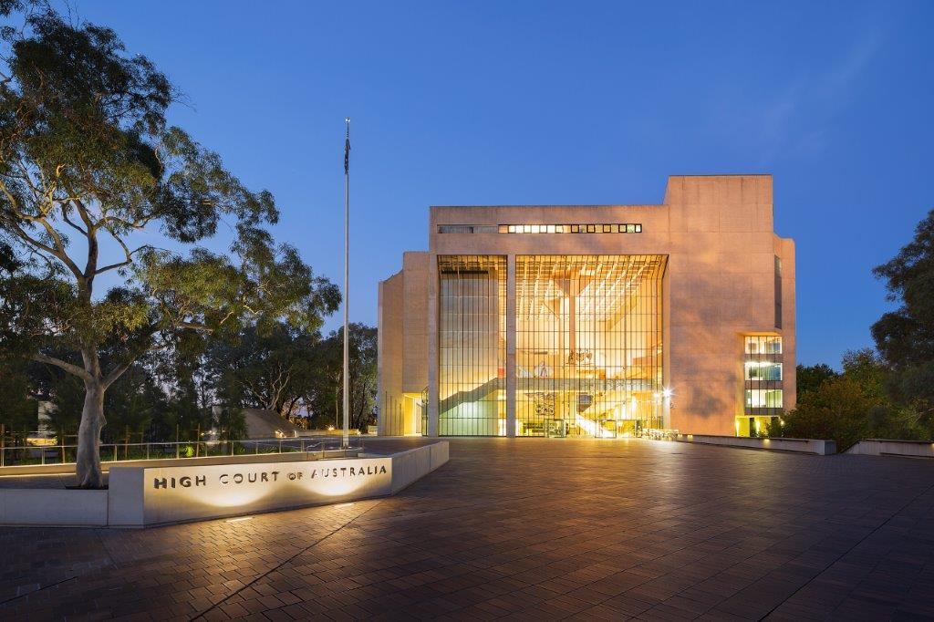

# Vacancy Information Kit

|  |  |
| --- | --- |
| **Position details** | |
| Position number | 129 |
| Position title | Property Projects Manager |
| Classification | High Court Employee Executive Level 1 ($119,074 — $132,232) |
| Location | Canberra, ACT |
| Working arrangements | Non-Ongoing for 18 months |
| Eligibility | Employees of the High Court are required to be Australian citizens. |
| Contact officer | Chris O’Neill  Tel: 02 6270 6851 |
| Closing date | Sunday 31 August 2025 |

**About the High Court of Australia**

The High Court of Australia (the Court) is the highest court in the Australian judicial system. It was established in 1901 by section 71 of the Constitution.

The seat of the Court is in Canberra, where it is located in its own building within the National Triangle. The Court also has locations in Brisbane, Sydney, and Melbourne, as well as sitting on circuit around Australia as required.

Opened in 1980, the High Court building is one of Australia’s National Buildings, and was heritage listed in 2007.

The Court has approximately 75 full-time equivalent ongoing and casual employees supporting the Chief Justice and Justices, most of whom are located in Canberra.

As an employee of the Court, you will:

* work in a high-performing, inclusive and collaborative work environment
* receive a generous starting salary and work conditions
* have access to reasonably priced undercover car parking
* have access to flexible working arrangements.

# Branch overview

The Corporate Services Branch provides a high standard of support and guidance to the Court on general day-to-day requirements. This includes the Administration, Finance, Records Management, Risk and Governance, Information and Communication Technology (ICT) and Building Operations functions which support the operation of the Court.

Each of these key supporting areas of the Court play a pivotal role, ensuring all employees of the Court are able to successfully undertake the duties of their role within a safe, secure and suitable environment.

The Property Projects Manager reports to the High Court Marshal, Manager Facilities and Security.

This position is for a term of 18 months where the occupant will coordinate a range of capital works projects in the High Court building.

# What you need to be successful

# The Property Projects Manager is responsible for coordinating the Court’s capital works projects, ensuring they are delivered efficiently, safely, and in a manner consistent with Commonwealth public sector procurement requirements.

# To be successful in this role, you will bring extensive experience in project management within the construction or property sector, with a strong understanding of government procurement processes. You will have excellent organisational and communication skills, the ability to manage multiple stakeholders, and a proactive approach to problem-solving. A sound knowledge of Work Health and Safety (WHS) practices and the ability to interpret technical drawings and specifications is essential.

# The duties and responsibilities for this role include:

# planning and preparing procurement documentation for capital works projects

# interpreting construction plans and drawings to support project delivery

# engaging and liaising with clients, consultants, and contractors throughout the project lifecycle

# monitoring and promoting WHS practices, including conducting on-site inductions

# ensuring on-site productivity, efficiency, and adherence to project timelines

# building and maintaining strong working relationships with internal and external stakeholders

# conducting site inspections and preparing progress reports

# assisting in the review and evaluation of technical designs

# coordinating with Court staff to minimise disruption to Court operations during project delivery

# preparing detailed reports on project risks, costs, and progress

# Are you eligible to apply?

To be eligible for employment at the Court candidates must be Australian citizens.

Candidates offered employment will be required to successfully undergo a police record check and be able to obtain and maintain a Negative Vetting 1 security clearance. The successful candidate will be required to submit a pre-employment medical declaration. Candidates must be willing to disclose all relevant and required information.

# Successful applicants engaged by the Court will be subject to a probation period.

# What does the selection process look like?

The Court uses a range of assessment processes to assist us in selecting suitably qualified and experienced applicants. We uphold the Merit Principle, with our process designed to select the best person for the role.

|  |  |
| --- | --- |
| **What are the steps?** | |
| Apply | Complete and submit your application — see below (max. 750 words), and a résumé of no more than two pages. |
| Shortlist | Applicants for this process will be assessed on their written application against the selection criteria. |
| Interview | Shortlisted applicants will be invited to attend an interview. Interviews may be held in person, or by telephone or video. |
| Work Sample Test | Applicants may be asked to complete a work sample test either in person or remotely. |
| Referees | Referees may be contacted for further assessment of suitability. Applicants should choose referees who can comment effectively and accurately on their current skills and abilities, experience and work performance that is relevant to the duties of the position. |

|  |  |
| --- | --- |
| Process Complete | After the Chief Executive and Principal Registrar (CE&PR) has approved  the process, a merit pool may be established. All candidates will be notified of the outcome and will be provided with an opportunity for feedback. |

# What we need from you

Applications must be addressed to the contact officer and forwarded to the [HR Officer](mailto:hr.officer@hcourt.gov.au) by the closing date.

As part of your application, you will need to provide:

* an application cover sheet
* your current résumé
* a statement of claims (max. 750 words) against the selection criteria, including relevant examples
* the names and contact details of two referees, one of whom should be a current supervisor.

If you have any questions regarding the recruitment process or require any reasonable adjustments, please email the [HR Officer](mailto:HR.Officer@hcourt.gov.au) or telephone (02) 6270 6952.

***Please note that late applications will not be accepted.***

# Selection criteria

The selection criteria reflect the knowledge, experience, core skills, and personal qualities required for the Property Projects Manager role. Your written application should specifically address each of the following criteria, providing clear examples of your experience, achievements, and the outcomes you delivered:

* Demonstrated ability to lead and manage the end-to-end delivery of complex building or infrastructure projects within a public sector heritage listed building. This includes strategic planning, financial oversight, risk management, and ensuring compliance with relevant legislation and procurement frameworks.
* Proven capability to manage competing priorities and deliver outcomes in a dynamic and high-pressure environment, particularly in relation to contract management, tender processes, and the coordination of multiple concurrent projects. The ability to anticipate challenges and implement proactive solutions is essential.
* Extensive experience in procuring, coordinating, and managing multidisciplinary teams of consultants, contractors, and technical experts to deliver high-quality project outcomes. This includes developing procurement strategies, evaluating tenders, and ensuring alignment with organisational goals and value-for-money principles.
* Highly developed communication, negotiation, and stakeholder engagement skills, with a demonstrated ability to influence and collaborate effectively across all levels of an organisation, including senior executives, operational staff, and external service providers.
* Strong analytical and strategic decision-making skills, with the ability to exercise sound judgement, assess complex risks, and adapt project plans in response to evolving priorities or unforeseen challenges.
* Comprehensive understanding of Work Health and Safety (WHS) legislation, policies, and practices, particularly in the context of construction and facilities management. Demonstrated experience in promoting a culture of safety and ensuring compliance with WHS obligations across project sites.

|  |  |
| --- | --- |
| Qualifications and experience | |
| Highly Desirable | Project management qualifications or equivalent experience. |
| Desirable | Procurement and contract management qualifications or equivalent experience. |

# Preparing your statement of claims

Your statement should be succinct and showcase your skills, knowledge, experience and qualifications.

Try not to duplicate information that can be found in your résumé, however you should highlight:

* how your experience, abilities, knowledge and personal qualities would enable you to perform the duties and meet the technical and behavioral capabilities of the role
* any specific examples or achievements that demonstrate your ability to perform the role
* how you meet the eligibility requirements and qualifications for the position.

# Offers and merit pool

At the end of the recruitment process a merit pool may be created. Candidates who are found suitable will be advised that they have been placed in the merit pool, noting that this is not an offer of employment.

The merit pool is valid for 18 months from the date the process is advertised and may be used throughout the year to fill similar non ongoing positions in the event positions become vacant.

# How we will communicate with you

Please ensure that the contact information you supply is up to date. Your email address will be our primary point of contact during the application process.

Please contact the [HR Officer](mailto:HR.Officer@hcourt.gov.au) if at any stage you are no longer available to be considered for this role.

|  |  |
| --- | --- |
| **Application Cover Sheet** | |
| Position Title | Property Projects Manager |
| Position Classification | High Court Employee Executive Level 1 |
| **Personal Details** |  |
| Given Names |  |
| Surname |  |
| Address |  |
| Contact No |  |
| Email |  |
| Are you an Australian citizen? |  |
| Are you currently a Commonwealth, APS or State government employee? | |
| Department name |  |
| AGS No |  |
| Substantive level |  |
| Ongoing /non-ongoing |  |
| Have you received a redundancy from a Commonwealth, APS or state government employer in the last 12 months? | |
| **Referee Details** |  |
| Referee No 1 - Name |  |
| Title / Organisation |  |
| Contact No |  |
| Email |  |
| Referee No 2 - Name |  |
| Title/Organisation |  |
| Contact No |  |
| Email |  |
| How did you hear about this vacancy? | |